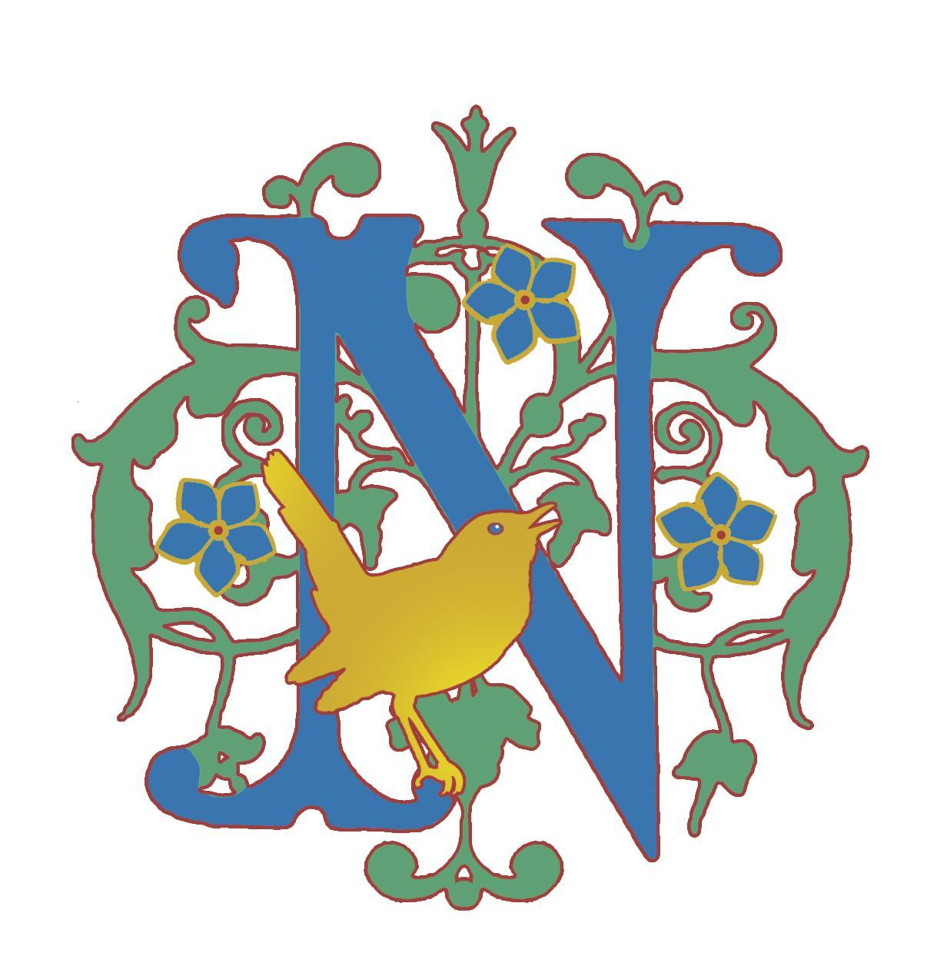
Health and Safety Policy

Aims
Nightingale Cottage aims to:
- Provide and maintain a safe, healthy and nurturing environment for children, staff, volunteers and visitors
- Take all reasonably practicable steps to ensure the health, safety and welfare of all those attending the provision
- Establish and maintain safe working procedures amongst staff, pupils, volunteers and visitors
- Have robust procedures in place in case of emergencies
- Ensure that the premises, outdoor environments and equipment are maintained safely and regularly inspected
- Promote safe and responsible behaviour during all activities, including outdoor learning and off-site visits

Health and Safety Lead
The nominated health and safety lead is Francesca Paul, who is responsible for:
- Implementing and reviewing the health and safety policy
- Ensuring appropriate staffing levels and supervision ratios are maintained according to the needs, ages and activities of the children attending
- Ensuring buildings, outdoor spaces and premises are safe and regularly inspected
- Ensuring appropriate evacuation procedures are in place in case of fire or other emergencies
- Ensuring all risk assessments are completed, monitored and reviewed regularly
- Ensuring accidents, incidents and health and safety concerns are appropriately recorded and responded to
- Ensuring appropriate first aid provision is available during sessions and visits

Risk Assessments
Risk assessments are carried out for activities, environments and outings where appropriate and are reviewed regularly.
Particular consideration is given to:
- Outdoor learning environments
- Uneven ground and seasonal hazards
- Weather conditions and sun exposure
- Animals and wildlife
- Use of tools and equipment
- Off-site visits and woodland walks
- Individual medical or behavioural needs of children attending
Reasonable adjustments and additional control measures will be implemented where necessary to support children safely.

Fire Safety
Fire risks are minimised through careful management of the environment. Smoking and vaping are prohibited, electrical equipment is limited and regularly checked, and children do not access cooking facilities or flammable substances.
Smoke alarms are tested regularly and exit routes are kept clear at all times.
In the event of a fire or emergency evacuation, children will leave the building immediately and assemble at the front of the cottage, where all children and adults will be accounted for.
Children will periodically practise evacuation procedures so they are familiar with how to leave the premises safely.

First Aid
At least one adult with appropriate first aid training will be present during sessions and off-site visits.
A stocked first aid kit will be available at all times, including during woodland walks and off-site activities.
Parents/carers will be informed of significant accidents, injuries or head bumps occurring during sessions.
Accidents and incidents will be recorded appropriately and reviewed where necessary to reduce future risks.
Please also see our First Aid Policy.

Off-site Visits
Occasionally, children may be taken on local walks or visits, including visits to nearby woodland areas. Permission for this is sought through the registration process.
When taking children off-site, Nightingale Cottage will ensure that:
- Appropriate risk assessments are completed
- Adults are familiar with the route and environment
- Visits are appropriately staffed and supervised
- At least one first aider is present
- An adult carries a mobile phone, first aid kit, emergency contact information and details of any relevant medical needs
Children will remain appropriately supervised at all times.

Outdoor Learning
A significant proportion of provision takes place outdoors. Parents/carers are responsible for ensuring children attend with appropriate clothing, footwear and weather protection, including sun cream where appropriate.
During periods of hot weather, children will have access to shade and drinking water and strenuous activities may be reduced.
Activities may be adapted, postponed or cancelled in unsafe weather conditions.

Smoking and Vaping
Smoking and vaping are not permitted anywhere on the premises or during activities involving children.

Infection Prevention and Control
Nightingale Cottage follows relevant public health guidance in relation to infection prevention and control.
Parents/carers are asked not to send children to sessions if they are unwell and may be at risk of spreading infection to others.
Children should usually remain at home if they:
- Have a fever/high temperature
- Are vomiting or have diarrhoea (children should remain away for at least 48 hours after the last episode of vomiting or diarrhoea)
- Are too unwell to participate comfortably in normal activities
- Have a contagious illness where exclusion is recommended by public health guidance
Parents/carers should inform Nightingale Cottage if their child has a significant illness or infectious condition.
Good hygiene practices are encouraged where appropriate.

Handwashing
- Wash hands with liquid soap and warm water
- Wash hands after using the toilet, before eating or handling food, after handling animals and after outdoor activities
- Cover cuts and abrasions with waterproof dressings

Respiratory Hygiene
- Cover coughs and sneezes with a tissue where possible
- Dispose of tissues promptly
- Wash hands after coughing, sneezing or nose wiping
- Encourage good respiratory hygiene amongst children

Cleaning of the Environment
- Toys, resources and frequently touched surfaces will be cleaned regularly
- Cleaning products and potentially hazardous substances will be stored securely and out of reach of children
- Cleaning equipment will not be accessible to children

Personal Protective Equipment (PPE)
Personal protective equipment will be used where appropriate to reduce the spread of infection or when managing bodily fluids.

Cleaning Blood and Body Fluid Spillages
- Spillages will be cleaned promptly using appropriate protective equipment
- Disposable paper towels will be used where possible
- Suitable cleaning and disinfecting products will be used according to manufacturer guidance
- Waste will be disposed of safely and hygienically

Animals
Children may occasionally interact with animals as part of the provision.
To reduce risks:
- Hands must be washed after handling animals
- Animal living areas will be kept clean and away from food preparation or eating areas
- Animal waste will be disposed of appropriately
- Children will be supervised around animals at all times

Allergies and Medical Needs
Parents/carers must inform Nightingale Cottage of any allergies, medical conditions, dietary requirements or emergency medication needs before attendance.
Where necessary, individual healthcare arrangements or risk management procedures will be put in place.
Emergency medication, such as inhalers or adrenaline auto-injectors, must be clearly labelled and easily accessible.

Administering Medication
Medication will only be administered where necessary for a child’s health or wellbeing and with prior written parental consent.
All medication must:
- Be in date
- Be in its original packaging
- Include the original instruction leaflet
- Be clearly labelled with the child’s name where appropriate
Medication will only be administered according to the instructions provided by the parent/carer or medical professional.
Medication will be stored safely and out of reach of children, while ensuring emergency medication remains quickly accessible.
A written record will be kept of any medication administered, including:
- The child’s name
- The medication given
- The date and time
- The dosage
- Who administered it
- Parent/carer consent
Long-term medication arrangements may require supporting medical information.

Clothing
As much of the provision takes place outdoors, children are expected to attend in suitable clothing and footwear for the weather and activities planned.
Parents/carers are responsible for ensuring children are appropriately dressed and have suitable sun protection where required.

Visitors and External Practitioners
Visitors and external practitioners are expected to follow Nightingale Cottage’s health and safety procedures and safeguarding requirements.
Appropriate checks, insurance documentation and risk assessments will be obtained where necessary.
Children will remain appropriately supervised during activities led by external practitioners.

Security and Supervision
As an outdoor and home-based provision, absolute physical security cannot be guaranteed; however, reasonable measures are taken to maintain a safe environment.
Children are supervised at all times unless using the toilet independently. Children must inform an adult before leaving the main group.
Staff and volunteers will avoid situations where they are working alone with a child out of sight of others unless unavoidable and in line with safeguarding procedures.

Accident Reporting
Accidents and injuries will be recorded appropriately.
Parents/carers will be informed of significant accidents, injuries or incidents occurring during sessions.
Serious incidents will be reviewed to identify whether further safety measures or changes to risk assessments are required.
Please also see our First Aid Policy.

Child Protection and Safeguarding
Health and safety concerns that may also relate to safeguarding will be managed in accordance with the Safeguarding and Child Protection Policy.
Please also see our Safeguarding and Child Protection Policy.

Updated: 17.05.26
Review Date: 17.05.27

